Summary chapters of course Linux
Chapter one:
- Whoami
The Whoami is command displays the username of the account currently logged into the Linux operating system. It helps users identify which account is executing commands. This is especially useful when working with multiple user accounts or when switching between normal users and the root account.

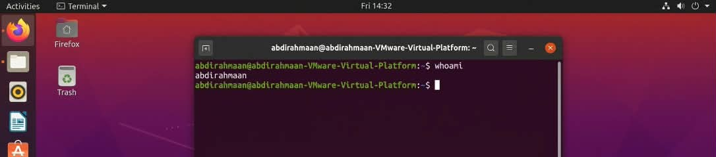

- Pwd(Print Working Directory)

The pwd command displays the full path of the directory in which the user is currently working. It helps users understand their current location in the Linux filesystem before creating, copying, moving, or deleting files.

- Pwd -l=Displays the logical current directory path, preserving symbolic links where possible.
  - Pwd -P=Displays the physical current directory path, resolving symbolic links.

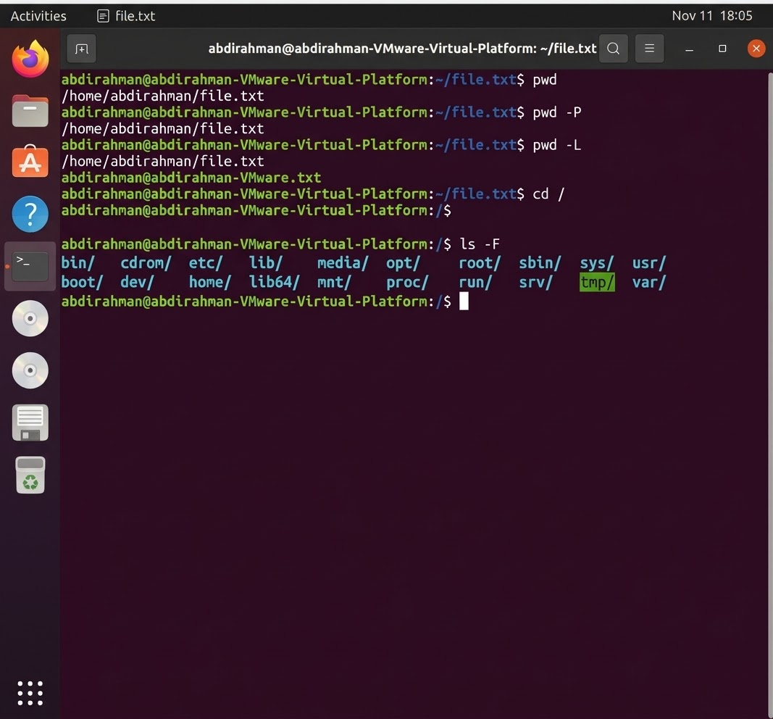

- Ls(List Files and Directories)
The ls command displays a list of files and directories stored in the current working directory or in a specified location. It helps users explore the Linux filesystem and identify available files, folders, permissions, ownership, and file sizes.

- Ls -l(long format)= Displays files in long format, showing permissions, ownership, file size, modification date, and name.
- Ls -a(all)= Displays all files, including hidden files and directories whose names begin with a dot.
- Ls -la =Displays all files, including hidden files, in long format.

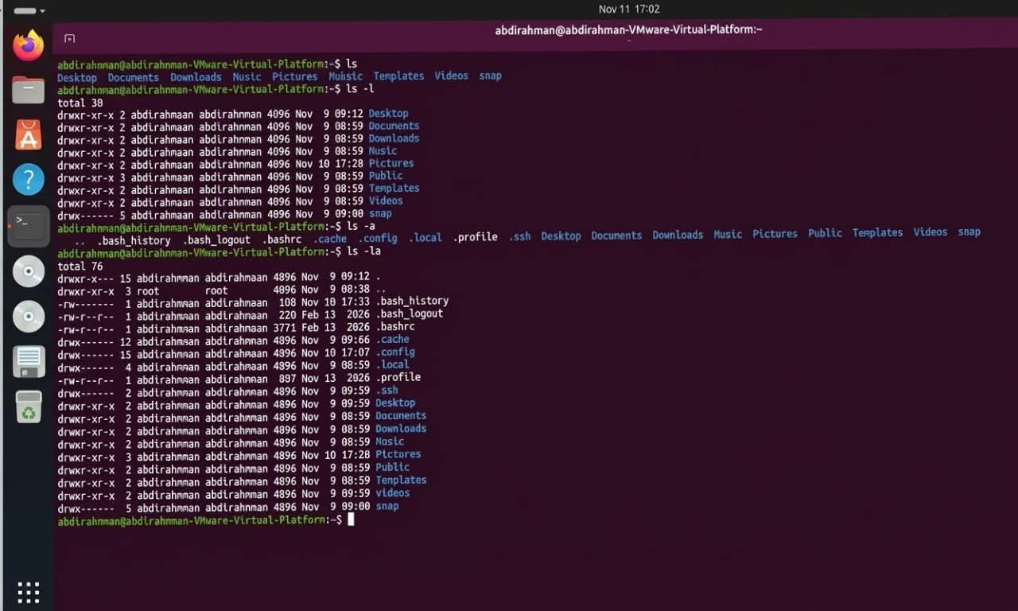

- Cat

The cat command is used to read and display the contents of text files directly in the terminal. It can also combine multiple files and send their contents to another file.

    - Cat file.txt=View content.
    - Cat -n=Number all lines.
    - Cat -b=Number non-empty lines only.
    - Cat -s=Squeeze multiple blank lines into one.
    - Cat -E=Show $ at the end of each line.
    - Cat >file.txt=Create a new file (overwrites existing content).
    - Cat file1>file2=Copy content from file1 into file 2.
    - Cat file1>>file2=Append content of file1 to the end of file2.

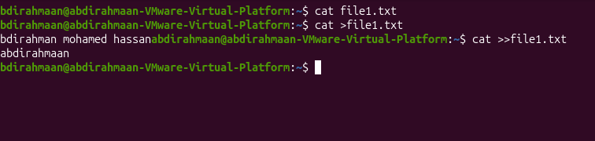

- Uname

The Uname command displays information about the operating system's kernel and hardware platform. It is commonly used by Linux administrators and users to identify the kernel name, kernel release, machine architecture, and other system details.

    - Uname -a=Displays all available system information provided by uname.
    - Uname -r=Displays the kernel release version.
    - Uname -m=Displays the machine hardware architecture
    - Uname -s=Display the karnel name.
    - Uname -o=Displays the operating system name, if supported.

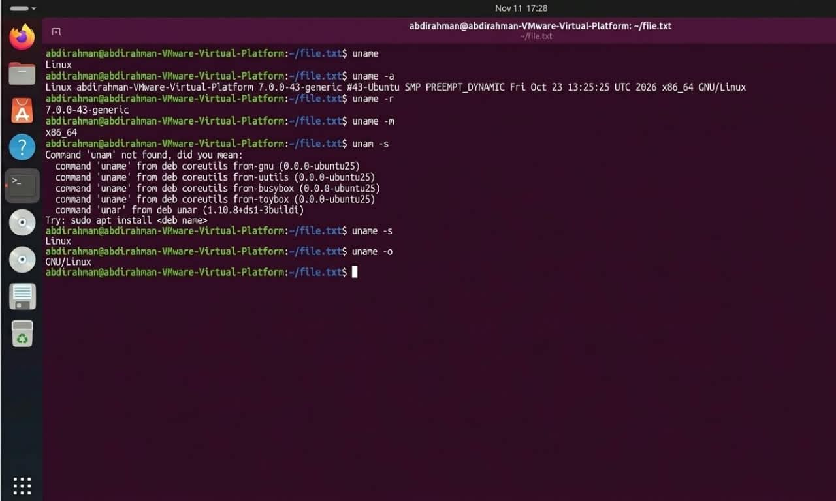

- apt– Advanced Package Tool
The apt command is a package management tool used in Ubuntu and other Debian-based Linux distributions, It allows users to install, update, upgrade, remove, and manage software packages through the terminal, a package is a collection of files and information required to install a software application.

- apt update=Refreshes the local package index by downloading information about available packages from configured repositories.
- apt upgrade=Installs available updates for currently installed packages.
- apt install package=Downloads and installs a specified software package.

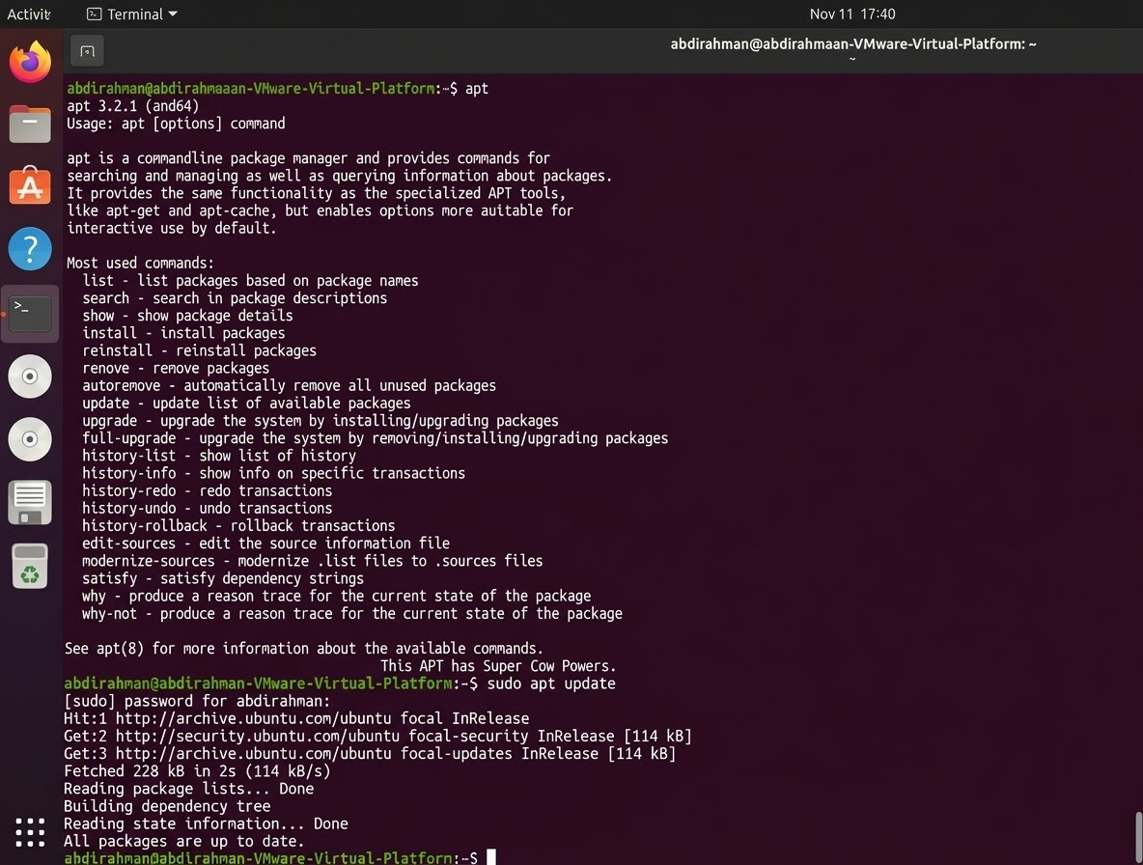

- dpkg – Debian Package Manager
The dpkg command is a low-level package management tool used in Debian-based Linux distributions, including Ubuntu, It is responsible for installing, removing, and managing software packages distributed in ,deb file format. Unlike APT, dpkg does not automatically download dependencies from online repositories.

- dpkg -i=Installs a Debian package from a local.
- dpkg -r=Removes an installed package but normally keeps its configuration files.
- dpkg -l=Lists packages known to the package management system.
- dpkg -S=Identifies which installed package owns a specified file.

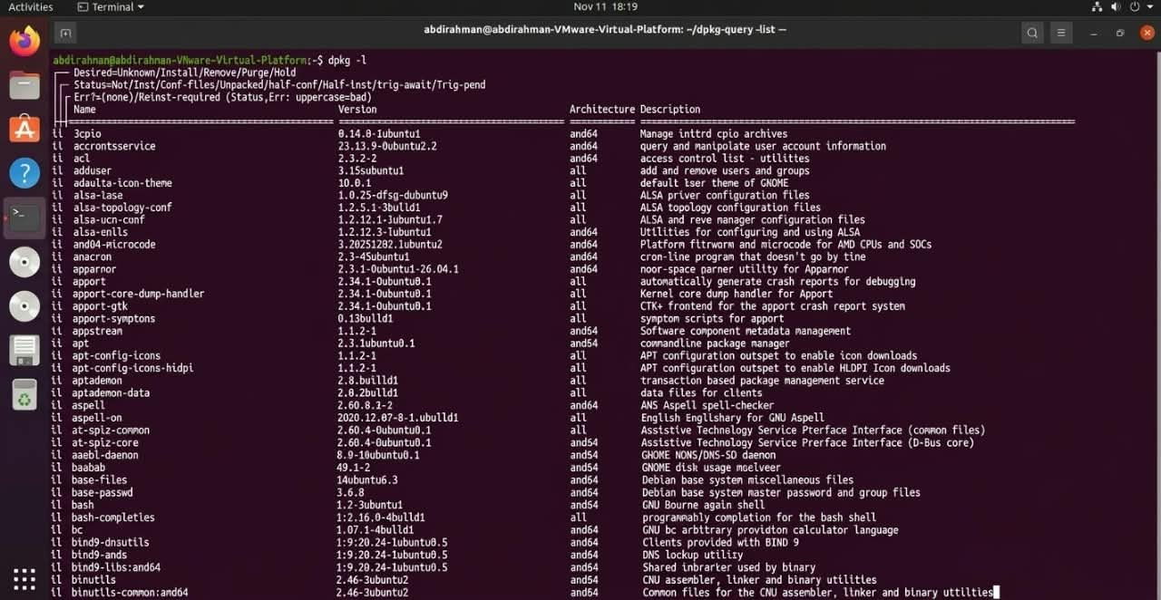

- cd – Change Directory
The cd command is used to change the current working directory in a Linux terminal. It allows users to navigate between directories in the filesystem. Although it is mentioned in the Chapter 1 presentation as a topic for the next chapter, it is useful to understand when learning Linux commands.

- cd /home=Changes the current directory to /home.
- cd ..= Moves one level up to the parent directory.
- cd ~=Changes to the current user's home directory.
- cd /=Changes to the root directory.
- cd -=Returns to the previous working directory.

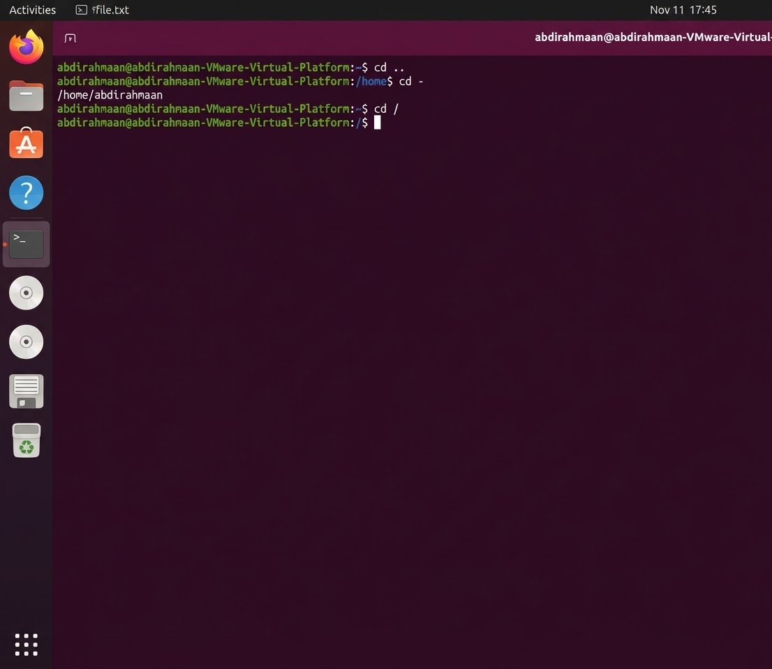

Chapter Two:
- history
The history command is displays a list of previously executed commands in the terminal. It helps users review commands they have entered before and repeat previous operations without typing them again.

- history -c=Clears command history.
- history -d=Deletes a history entry.
- history -w=Saves history to a file.

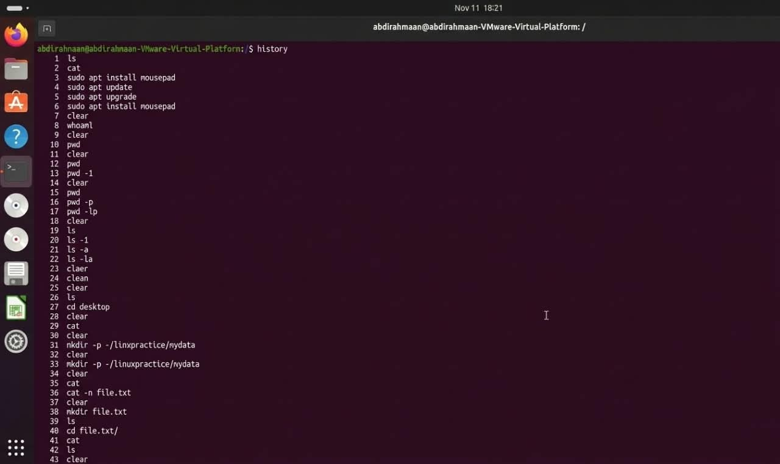

- man – Manual
The man command provides detailed documentation about Linux commands. It explains how commands work, their available options, and how they should be used. It is an important tool for learning and understanding Linux commands.

- man -k= Searches manuals by keyword.
- man -f= Shows a short command description.
- man -a= Displays all matching manual pages.

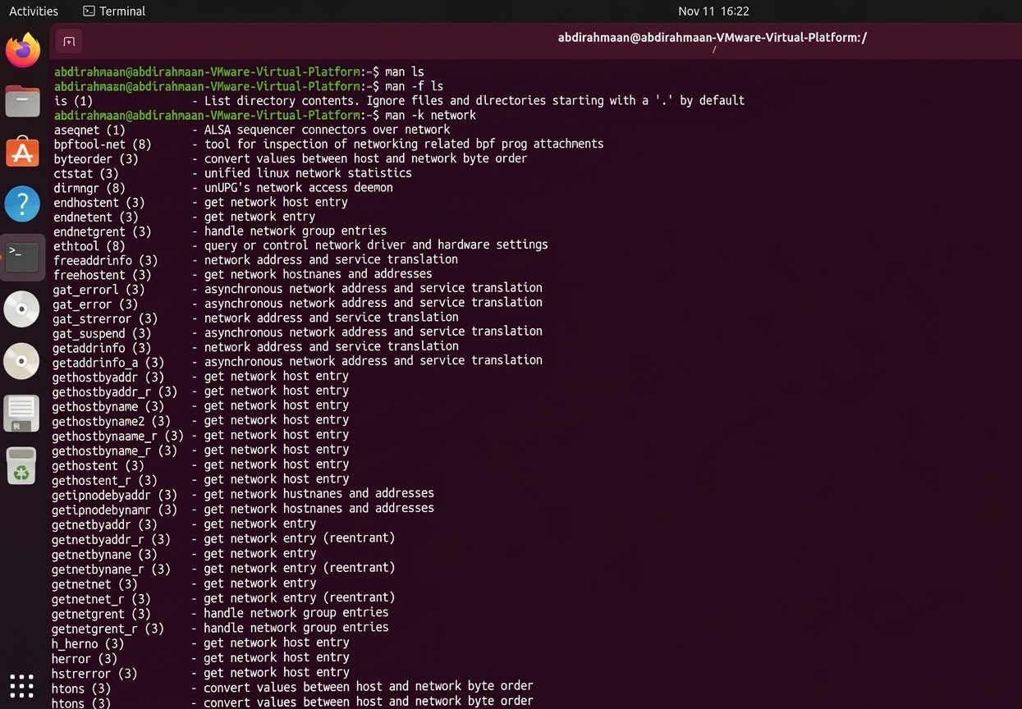

- Info
The info command displays detailed documentation about Linux commands and programs. It provides information in organized sections, allowing users to understand how different commands and tools work.

- info -k= Searches documentation by keyword.
- info -d= Specifies the documentation directory.

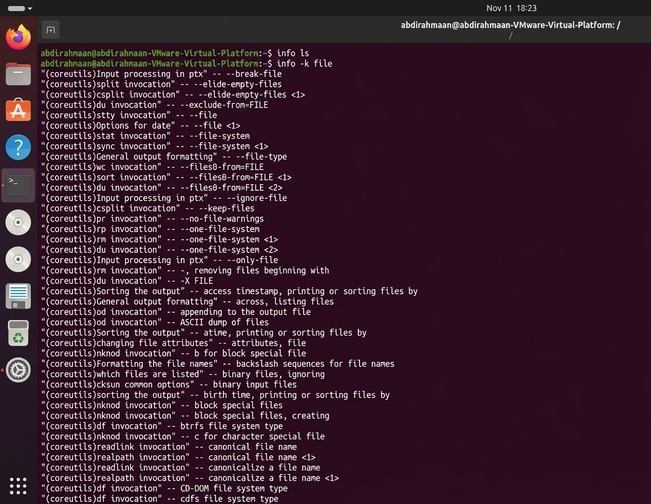

- help
The help is command provides information about Bash built-in commands. It explains the purpose, usage, and available options of commands that are built directly into the Bash shell.

- help -d= Displays a short description.
- help -s= Displays a short usage format.
- help -m= Displays manual-style information.

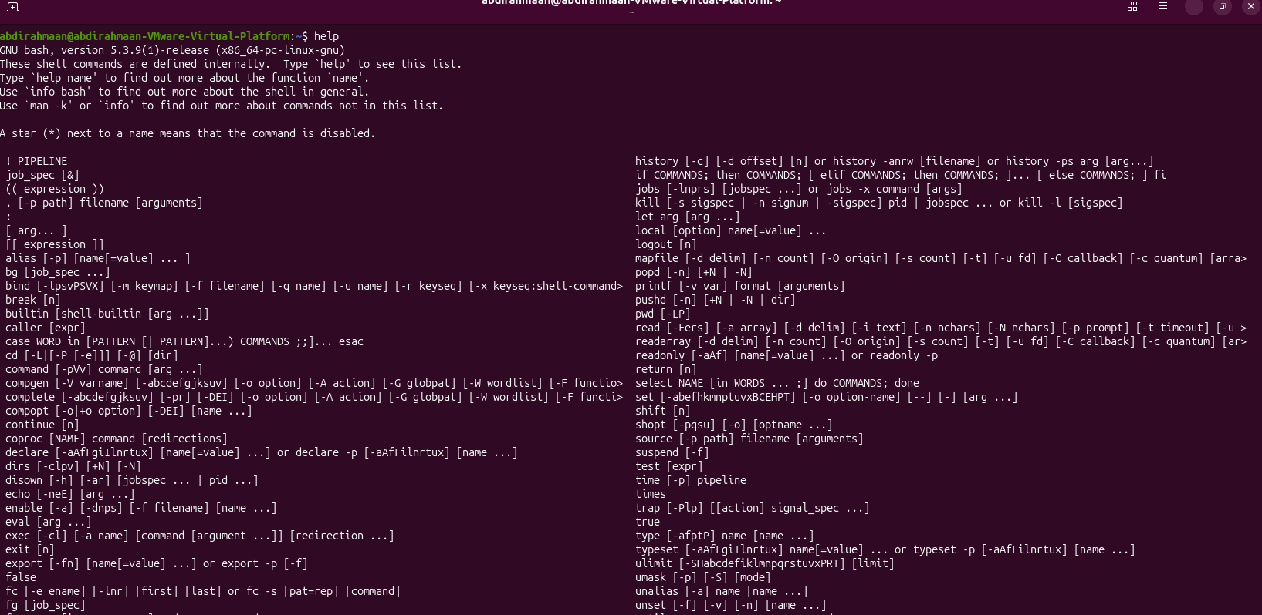

- echo
The echo is command displays text, messages, and variable values on the terminal screen. It is commonly used in shell scripts to print information and show the contents of variables.

- echo -n= Prevents a new line.
- echo -e= Enables escape characters.
- echo -E= Enables escape characters.

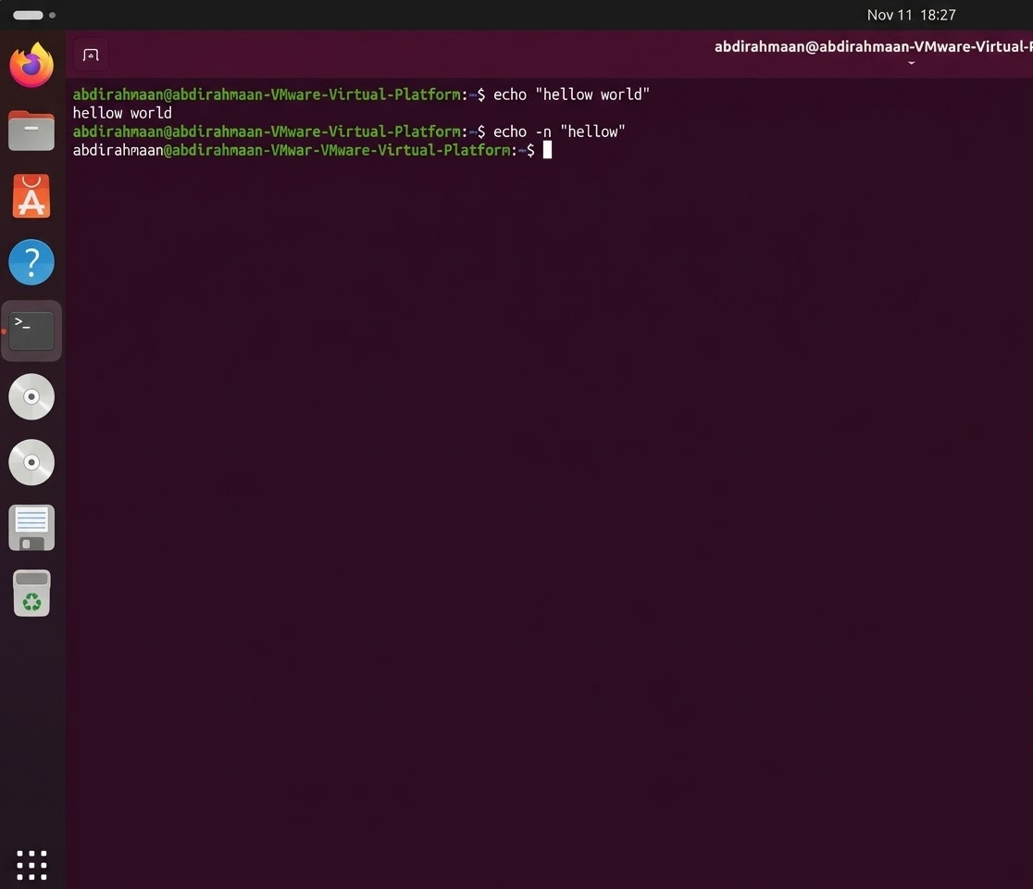

- mkdir (make directory)
The mkdir command is creates new directories in the Linux file system. It allows users to organize their files by creating separate folders for different tasks, projects, and documents. Users can create one or multiple directories using this command.

- mkdir -p= Creates parent directories.
- mkdir -m= Sets directory permissions.
- mkdir -v= Displays creation messages.

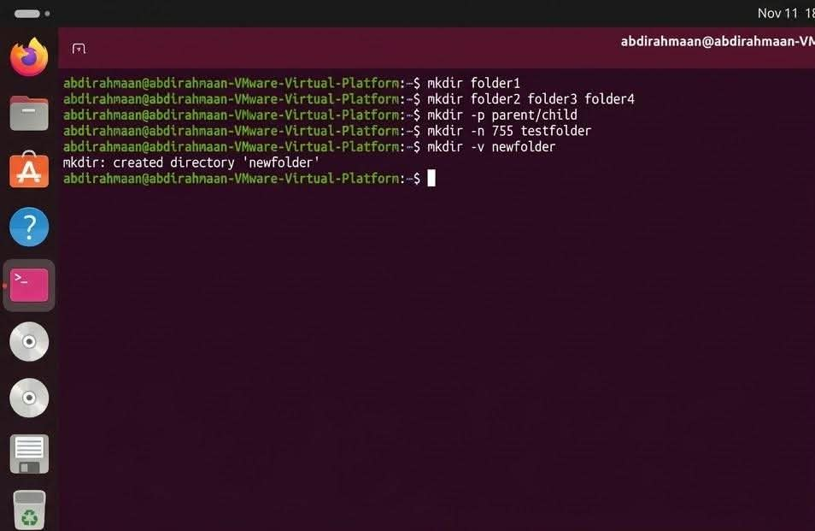

- Touch
The touch command is creates an empty file when the specified file does not exist. If the file already exists, it updates its access and modification timestamps. It is commonly used when creating new files quickly from the terminal.

- touch -a= Changes access time.
- touch -m= Changes modification time.
- touch -c= Prevents creating a new file.
- touch -t= Sets a specific timestamp.

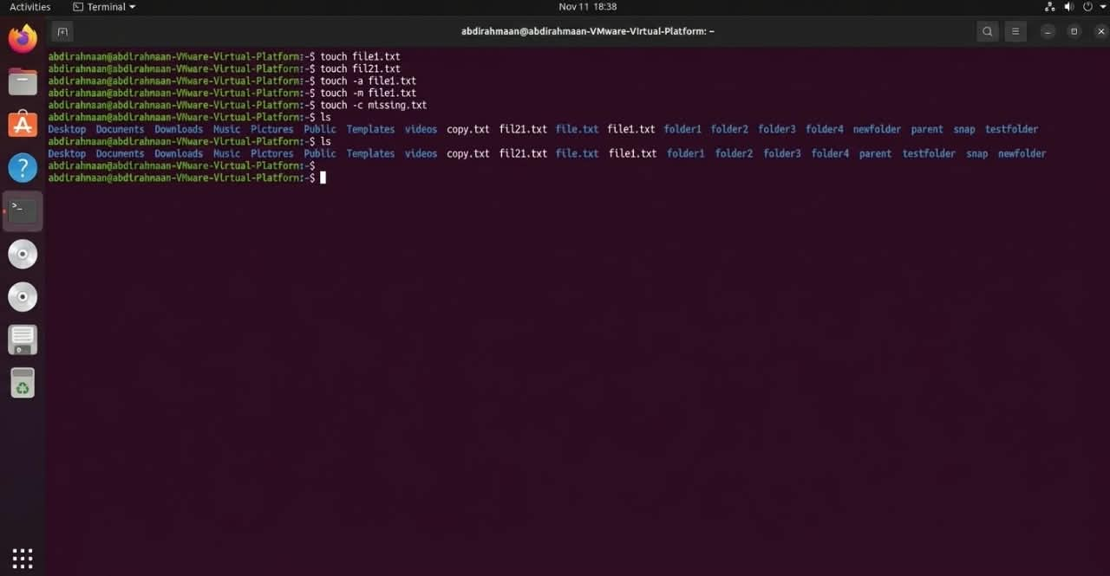

- rm (remove)
The command deletes files and directories from the Linux file system. It allows users to remove unnecessary files and manage storage space. When deleting directories that contain files, recursive removal is required. Users should be careful because deleted files may not be easily recoverable.

- rm -r= Removes directories recursively.
- rm -f= Forces deletion.
- rm -i= Asks before deletion.
- rm -v= Displays deleted files.
- rm -d= Removes empty directories.

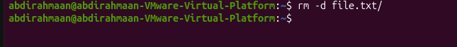

- export
The export command is makes shell variables available to child processes. It is commonly used to set environment variables that programs and other commands can access. For example, it can be used to configure the PATH variable.

- export -p= Displays exported variables.
- export -n= Removes export status.
- export -f= Exports a shell function.

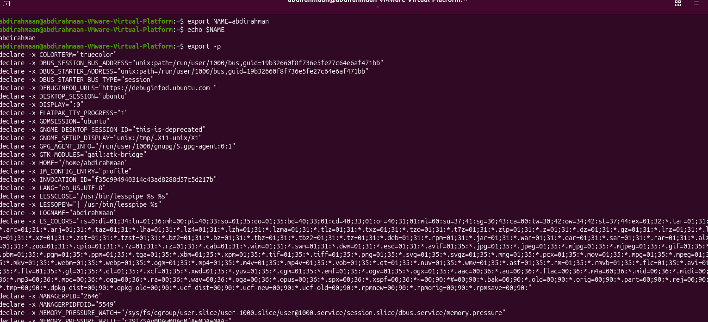

- Source
The source command reads and executes commands from a specified file in the current shell environment. It allows changes made in configuration files to take effect without closing and reopening the terminal. It is commonly used with.

- source ~/.bashrc =Reloads the user's Bash configuration.

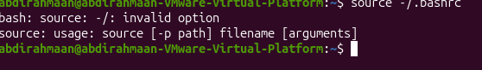

Chapter 3:
- less
An interactive pager tool that allows you to read long text files one screen at a time without modifying their contents, It provides smooth navigation forward and backward, plus search capabilities.

- less Space=Scrolls forward by one full screen.
- less b = Scrolls backward by one full screen.
- less /pattern = Searches forward for a specific word or pattern.
- less n =Jumps to the next match of the search pattern.
- less q =Quits and exits the pager.



- more
A basic pager tool used to view long text files one screen at a time, primarily moving forward. It offers simpler functionality compared to less.

- more Space = Advances to the next screen page.
- more q = Exits the viewer.

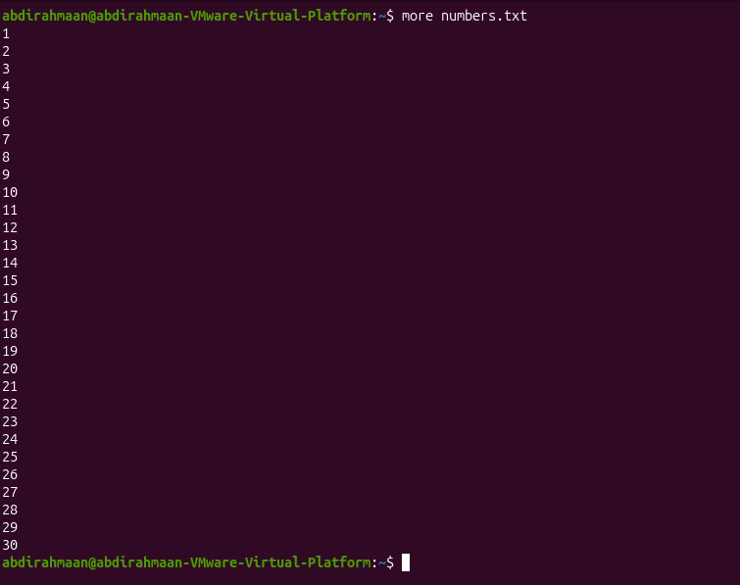

- head
Displays the beginning lines (top section) of a file without needing to open the entire file. It defaults to showing the first 10 lines if no specific count is given.
- head -n <number> =Specifies the exact number of lines to display from the top.

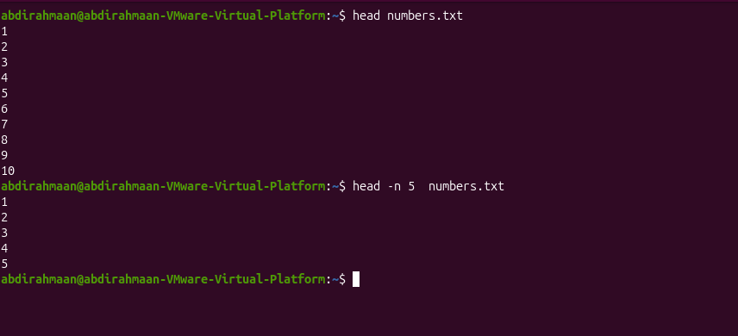

- tail

Displays the ending lines (bottom section) of a file without opening the whole file. It is especially useful for inspecting recent log entries appended at the end.
  - tail -n <number> = Specifies the exact number of bottom lines to display.
  - tail -f = Monitors a file in real-time, continuously displaying newly added lines.

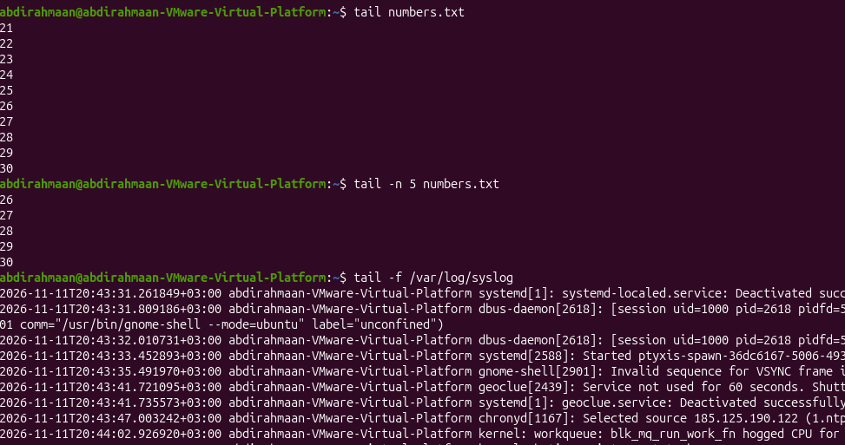

- file
Determines and identifies the actual file format or file type. It relies on internal content inspection rather than filename extensions.
- filename=Inspects the specified file to report its format (e.g., PDF, text, binary).

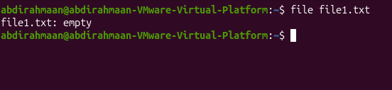

- which
Locates and displays the full executable binary path of a command. It performs this search by looking through directories listed in the $PATH environment variable.
- command_name = Searches $PATH for the specified program (e.g., which ls).

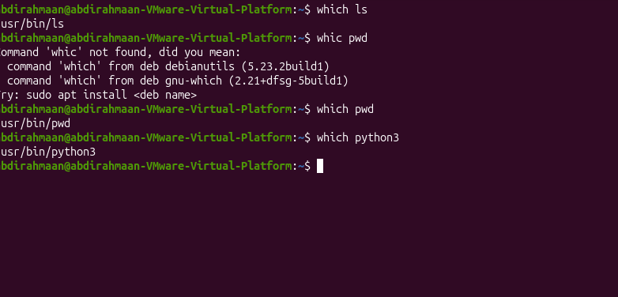

- type
Determines how a command is interpreted by the shell. It distinguishes whether a command is a shell built-in, external binary file, alias, or function.
- command_name : Checks command classification (e.g., type cd).

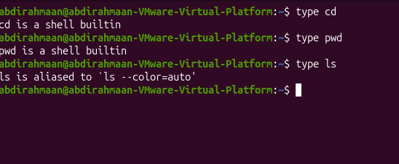

- whereis
Locates the binary executable files, source code files, and manual pages associated with a Linux command. It scans standard system directories.
- command_name = Searches system directories for related binaries and docs.
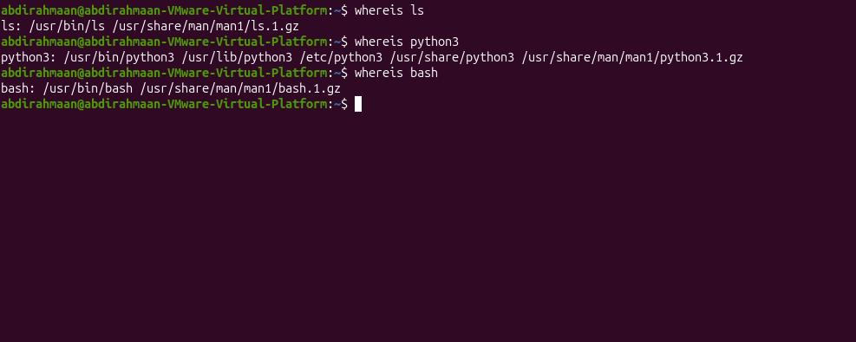

- find
Searches for files and directories in real-time across the directory tree. It filters results based on conditions like names, types, sizes, permissions, and age.
  - find -type f =Restricts search results to regular files only.
  - find -type d = Restricts search results to directories only.
  - find -size +10c =Matches files larger than specified size units (c=bytes, k, M, G).
  - find -mmin -30 =Matches files modified within a specific timeframe in minutes.
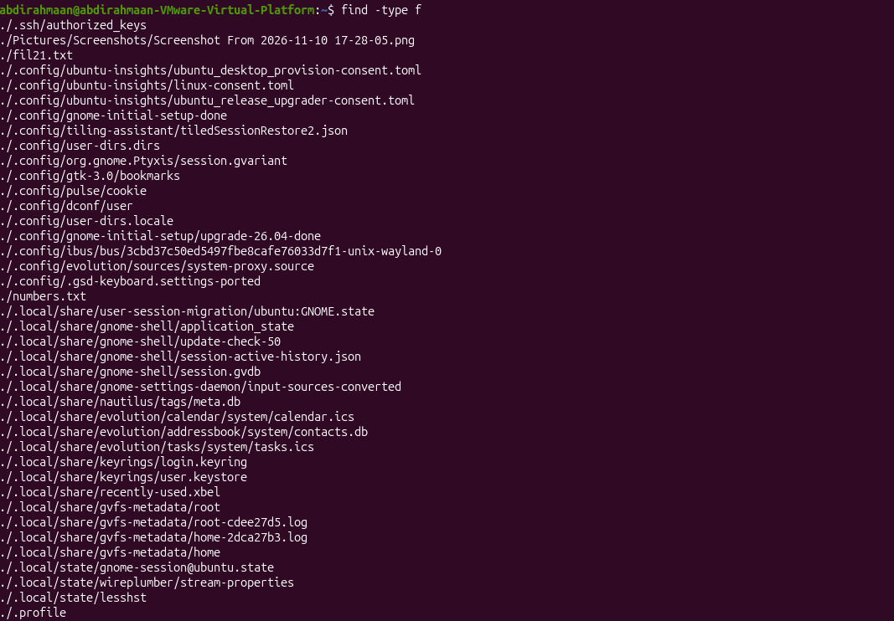

- locate
Finds files and directories quickly by querying a prebuilt database index of file paths. This avoids scanning the live filesystem directly, making broad lookups faster.
- filename = Quickly looks up file location from the indexed database.

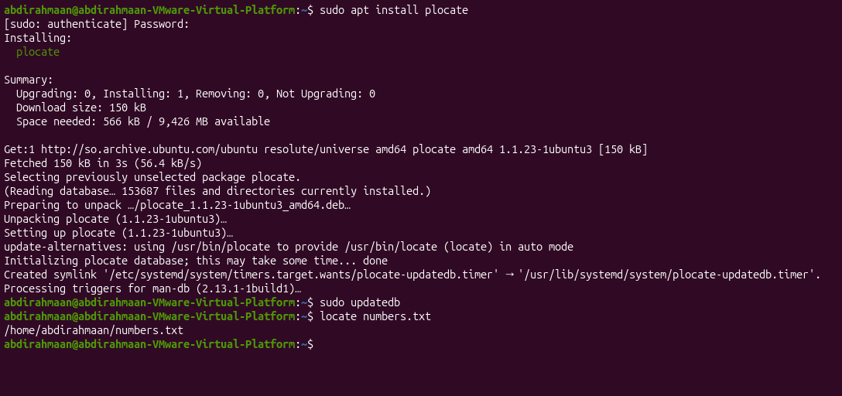

- updatedb
Refreshes and updates the file path database used by the locate command. It typically requires administrator privileges to index new files.

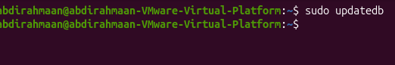

- grep
Searches for specific text or patterns inside files (Global Regular Expression Print). It displays only the lines that match the search pattern.
- grep -i = Ignores letter case differences during search.
  - grep -n = Displays line numbers alongside matching lines.
  - grep -v = Inverts match, hiding matching lines and showing remaining ones.
  - grep -r = Recursively searches through files inside subdirectories.
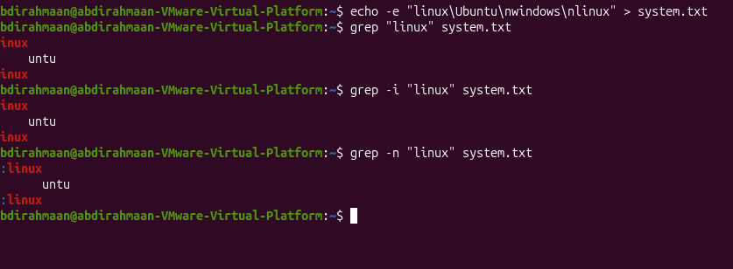

Redirection, Pipes, and Text Processing

1. >
Standard output redirection operator that sends a command's stdout to a file instead of the screen. It creates a new file or overwrites an existing one.

2. >>
Append output redirection operator that sends stdout to a file. It adds new data to the end of the file without erasing previous content.

3. 2>
Standard error redirection operator used to save error messages (stderr, file descriptor 2) to a file. It can also discard errors entirely when directed to /dev/null.

4. <
Standard input redirection operator that feeds the contents of a file into a command as stdin. It replaces keyboard input with file input.

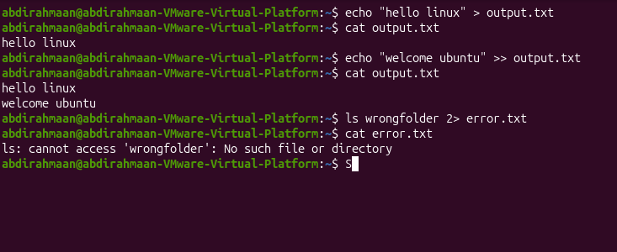

tr
Translate command used to replace, delete, or squeeze individual characters. It reads strictly from standard input and outputs to standard output.
  - tr 'a-z' 'A-Z' =Maps lowercase characters to uppercase.
  - tr -d '<chars>' =Deletes specified characters from input.
  - tr -s '<char>' =Squeezes repeated consecutive characters into a single instance.
- tar
Tape Archive utility used to bundle multiple files and directories into a single archive file. It can also apply compression algorithms in a single step.
  - tar -c =Creates a new archive.
  - tar -x = Extracts files from an archive.
  - tar -v = Verbose mode to display processed filenames.
  - tar -t = Lists contents of an archive without extracting.

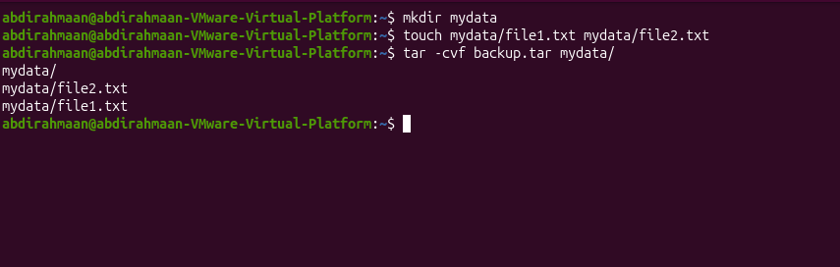

- nano
A simple, beginner-friendly command-line text editor. It displays essential shortcut keys clearly at the bottom of the screen.
- Keyboard Shortcuts:
  - Ctrl+O =Write Out (saves changes to disk).
  - Ctrl+X =Exits the editor.
  - Ctrl+W =Where Is (searches for text patterns).
  - Ctrl+K =Cuts the current line.
  - Ctrl+U = Uncuts (pastes) the line back.
  - Alt+U = Undoes the last editing change.

Chapter 4:

ps
Displays a snapshot of currently running processes attached to the terminal session.
- ps aux = Displays every process running across the system from all users with CPU and memory usage.
- ps -ef = Displays a full-format process listing showing parent-child relationships (PPID).
- ps -p PID = Filters the process snapshot to inspect only a specific Process ID.
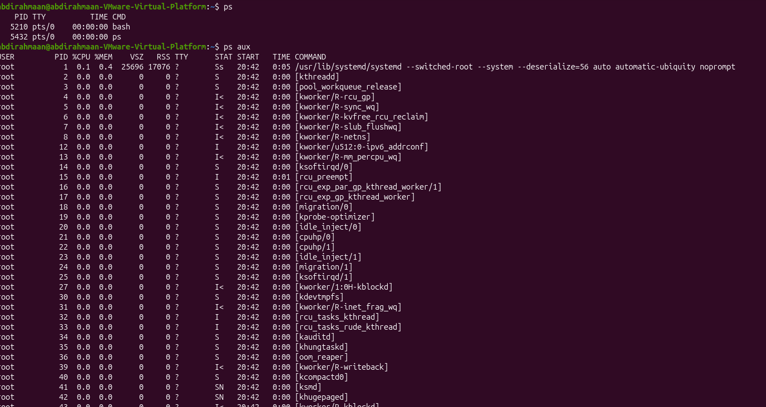

top
Provides a dynamic, real-time live view of running processes, CPU, and RAM usage.
- top -u USER = Restricts the live top view to display only processes owned by a specific user.
- top (M key) = Sorts the live process table by memory consumption (RAM).
- top (P key) = Sorts the live process table by CPU utilization.
- top (k key) = Prompts to kill a process directly inside top by entering its PID.
- top (q key) = Quits and exits the interactive top viewer.
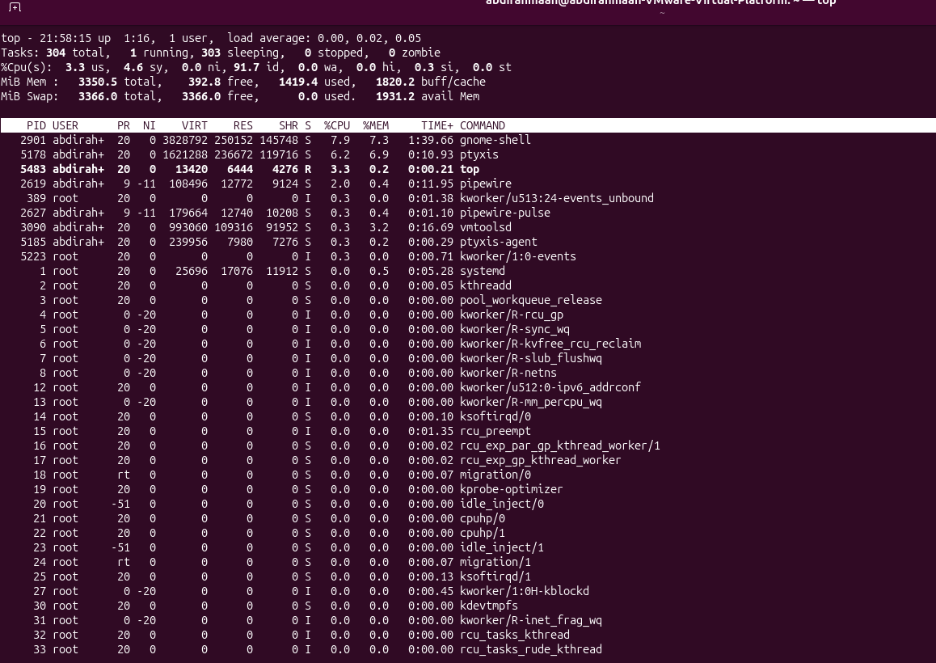

bg
Resumes a suspended/stopped job in the background.
- bg %N = Resumes job number N in the background (e.g., bg %1).

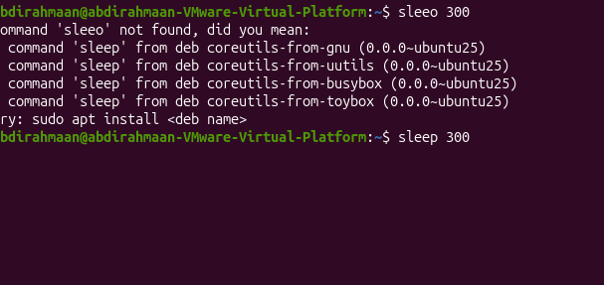

fg
Brings a background or suspended job into the foreground.
- fg %N = Brings job number N back to the foreground (e.g., fg %1).

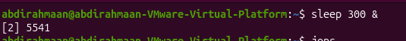

kill
Sends a control signal to a specific process using its Process ID (PID).
- kill PID = Sends SIGTERM (Signal 15) to politely request a process to stop and save data.
- kill -9 PID = Sends SIGKILL (Signal 9) to forcefully terminate a process immediately (last resort).
- kill -HUP PID = Sends SIGHUP (Signal 1) to ask a daemon to reload its configuration.

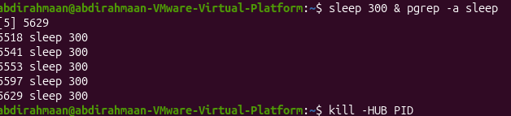

hostnamectl
Displays hostname, OS release, kernel version, and virtualization status.
- hostnamectl = Outputs the full summary block of OS and virtual hardware information.
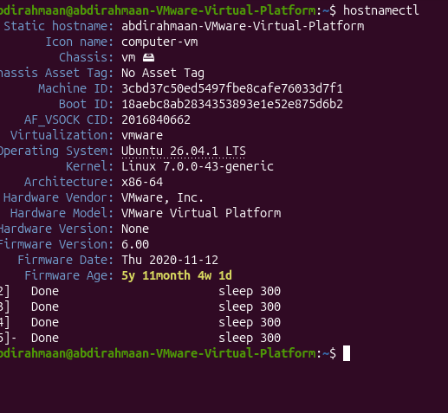

free
Reports total, used, free, and available RAM and Swap memory.
- free -h = Displays memory in human-readable units (GiB, MiB) focusing on available RAM.

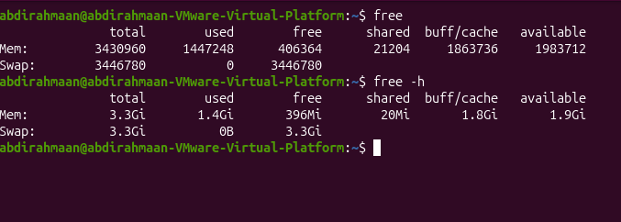

systemctl status
Displays operational status, active state, and recent logs of a service daemon.
- systemctl status UNIT = Displays full status for a service (e.g., systemctl status cron).
- systemctl is-active UNIT = Checks if a service is currently running (active/inactive).
- systemctl is-enabled UNIT = Checks if a service is set to start at boot (enabled/disabled).

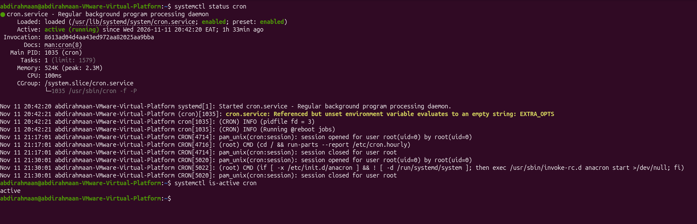

shutdown / reboot / poweroff
Commands used to cleanly stop services and turn off or restart Linux.
- sudo shutdown -r +5 "Message" = Schedules a reboot in 5 minutes with a warning message.
- sudo shutdown -c = Cancels a scheduled shutdown or reboot.
- sudo reboot = Restarts the system immediately.
- sudo poweroff = Powers off the system hardware cleanly.

